**CS6110 - Object Orientated Analysis and Design**

**SOCIAL NETWORKING SITE**

**Team Members**

|  |  |
| --- | --- |
| **Srivatsav R** | **2019103066** |
| **Sachin Raghul T** | **2019103573** |
| **Sanjeev KM** | **2019103576** |

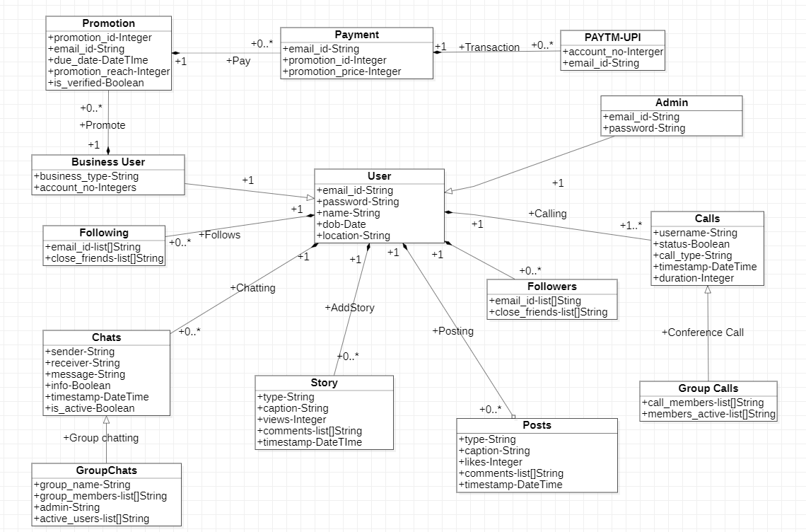DCM DIAGRAM :-